19.Write a Prolog program for STUDENT-TEACHER-SUB-CODE.
Name:S.VIGNESH
Reg.No:192512378

Aim
To write and execute a Prolog program to represent the relationship between students, teachers, subjects, and subject codes, and to retrieve the corresponding information using Prolog queries.
Algorithm
- Start the program.
- Define the facts for different students.
- Define the facts for different teachers.
- Define the subjects along with their subject codes.
- Define which teacher teaches each subject.
- Define which subjects each student studies.
- Create a rule student_teacher_subject/4 to connect the student, teacher, subject, and subject code.
- Load the Prolog program into SWI-Prolog.
- Enter a query with the required student name.
- Prolog matches the student's subject with the corresponding teacher and subject code.
- Display the matching results.
- Stop the program.

PROGRAM:
% Prolog Program for STUDENT-TEACHER-SUB-CODE
% Students
student(rahul).
student(priya).
student(anu).
student(kiran).
% Teachers
teacher(rajesh).
teacher(suresh).
teacher(meena).
% Subjects and Subject Codes
subject(ai, ai101).
subject(dbms, dbms102).
subject(networks, cn103).
subject(prolog, pl104).
% Teacher teaches Subject
teaches(rajesh, ai).
teaches(suresh, dbms).
teaches(meena, networks).
teaches(rajesh, prolog).
% Student studies Subject
studies(rahul, ai).
studies(rahul, dbms).
studies(priya, ai).
studies(priya, networks).
studies(anu, prolog).
studies(kiran, dbms).
% Rule to find Student, Teacher, Subject and Subject Code
student_teacher_subject(Student, Teacher, Subject, Code) :-
student(Student),
studies(Student, Subject),
teaches(Teacher, Subject),
subject(Subject, Code).

INPUT:
student_teacher_subject(rahul, Teacher, Subject, Code).
OUTPUT:
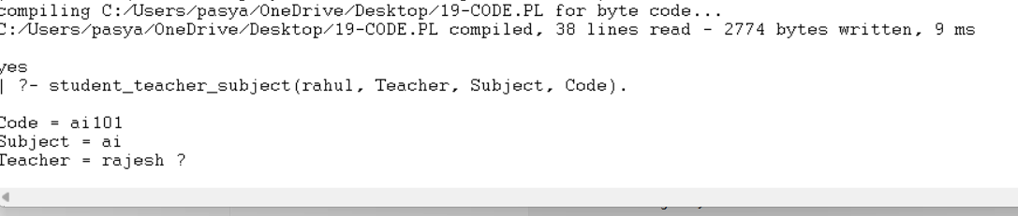

RESULT:
Thus, the Prolog program for STUDENT-TEACHER-SUB-CODE was successfully implemented and executed, and the corresponding teacher, subject, and subject code for a given student were obtained successfully.

